Half Yearly Progress Report on Research Work carried out from 28.09.2012 to 27.03.2013
Name and address of the candidate : P. Mohandass
Reg. No. P8851
PG and Research Dept. of Chemistry
Saraswathi Narayanan College
Madurai-22.

Occupation if any and address : Associate Professor of Chemistry
Saraswathi Narayanan College
Madurai-22.

Name, designation and address of the : Dr. K. Radhakrishnan
Guide Associate Professor of Chemistry
Saraswathi Narayanan College
Madurai-22.

College where the candidate carried : PG and Research Dept. of Chemistry
out the research Saraswathi Narayanan College
Madurai-22.

Whether the candidate has paid annual
Research fee (mention amount, date of : No
remittance, place of bank, etc.)

Detailed one page report on the progress : Separate sheet Attached
of research work carried out by the
candidate (attach separate sheet)

Remark, if any by the guide : Nil

Signature of the candidate Signature of the research supervisor

Half Yearly Progress Report on Research Work carried out from 28.09.2012 to 27.03.2013

Preparation of 4′-substituted 5-benzylidenebarbituric acids.
5-benzylidenebarbituric acid and its substituted compounds were prepared by the modified procedure.
To the calculated amount of the pure benzaldehyde (2 g, 0.015 mol) and barbituric acid (1.55 g, 0.015 mol) in warm ethyl alcohol was added a 10% solution of sodium hydroxide (catalytic amount) and the reaction mixture stirred for 2 hours. After completion of the reaction as indicated by TLC, the reaction mixture was left overnight. The solvent was removed in vacuum. The resulting crude product was purified by column chromatography.
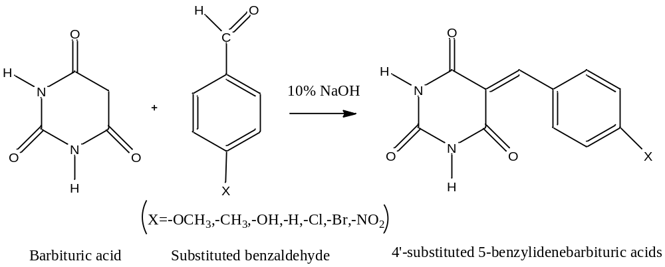

Signature of the research supervisor

